Extended Abstract Template for Nordic Flame Days 2019 (Title)
  - First Author^{1*}, Second Author¹, Third Author² (Subtitle)
¹Institution, Address, City, Country (Normal, font size 11, centred)
² Institution, Address, City, Country
*Email address of corresponding author

1. Template (Heading 1)
The four page extended abstract should be written in English. Suggested sections are introduction, material and methods, results and discussion, conclusion and references. (Normal)

1.1. Figures and Tables (Heading 2)
Please use the designated predefined styles (Title, Subtitle, Heading 1, Heading 2 and Normal); see Table 1 for specifications. Any deviations from the styles are specified in the text.
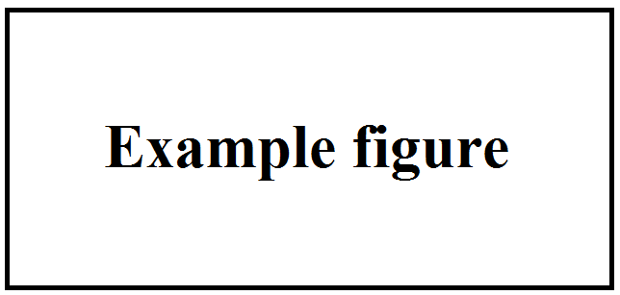
Figure 1. Figure caption. (Normal, font size 11, italic, centred.) Please use 2 cm indent on left and right for figure captions.
Figures and tables as well as their captions should be centred. Figures should be referred to as Fig. 1, unless it’s the first word in a sentence, then use Figure 1. To refer to several figures, use Figs 1-2 or Figs 1 and 3 (or Figures 1-2 in the beginning of a sentence).
Table 1. Table caption. (Normal, font size 11, italic, centred). Please use 2 cm indent on left and right for table captions. Table text: Normal, aligned to left, font size 10.
Style | Font | Font size | Text alignment | Spacing above | Spacing below
Title | Arial | 14 | Centred | 6 | 15
Subtitle | Arial, bold | 11 | Centred | 6 | 6
Heading 1 | Arial, bold | 12 | Left | 12 | 6
Heading 2 | Arial, bold | 11 | Left | 10 | 0
Normal | Times New Roman | 12 | Justified | 6 | 6
Tables should be referred to as Table 1 or Tables 1-2.

1.2. Equations and Reactions
Equations should be referred to as Eq. 1, unless it’s the first word in a sentence, then use Equation 1. To refer to several equations, use Eqs 1-2 (or Equations 1-2 in the beginning of a sentence). Please use a two-column table without borders for equations and reactions. Left-align the equation/reaction and right-align the numbering. Use a 1 cm indent on both sides:
$$x+y=z$$ | (1)
Refer to reactions as Reaction 1 or Reactions 1-2.
$$A+B↔C+D$$ | {1}

References (Heading 1)
Use square brackets when referencing; [1]. Write the references according to:
[1] Authors. Year. Title of paper. Journal, issue, pages. (Normal)
[2] Authors. Year. Book title. Publisher, City.
Examples:
[3] Gómez-Barea, A., Leckner, B. 2010. Modeling of biomass gasification in fluidized bed. Progress in Energy and Combustion Science, 36, 444-509.
[4] Kunii, D., Levenspiel, O. 1991. Fluidization Engineering. Wiley, New York.

